How to navigate

- Download the free Guidebook App.
- Open the app and click the “find guides”.

- 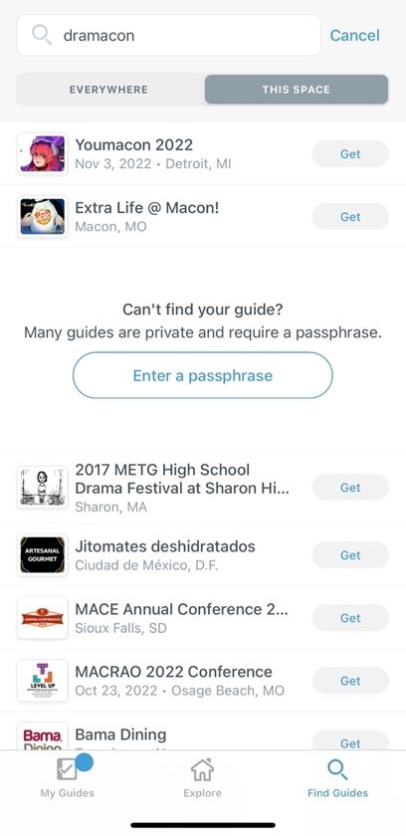
The easiest way to find our guide is by clicking here to enter the UTA Beyond Passphrase
- 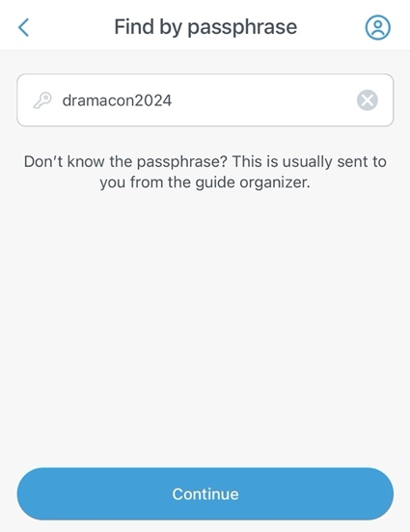
Our passphrase is “dramacon2024”

Our guide should be the first one! Click on it to enter!

- 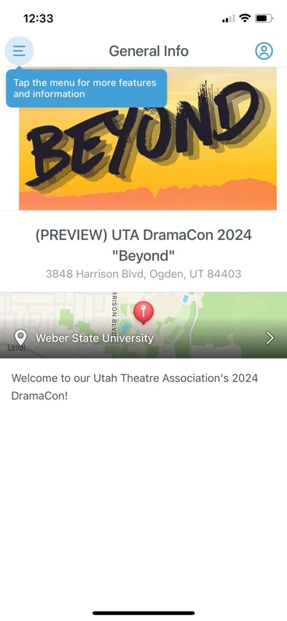
Once you are in the guide, click on the 3 lines to find the schedule and details.
- 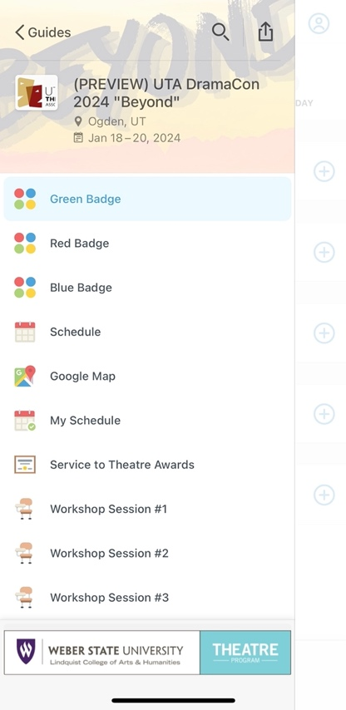
Here is where you will be able to scroll and find all the details of workshops as well as find the daily schedule. Please also look at the instructors bios and read all about our Service Award winners!

You can easily click on your color of badge and it will help navigate to your specific schedule.

Your schedule comes up broken up into each day for convenience. You can see what times the workshops are and then you can click the workshop you are ready to attend.

- 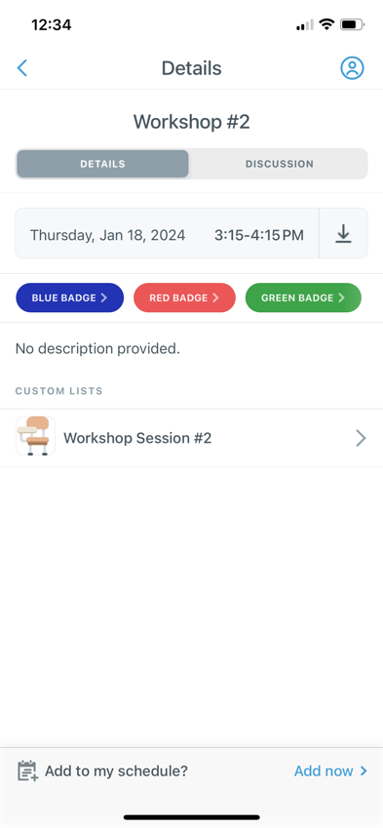
All the workshop descriptions will be under this link.

- 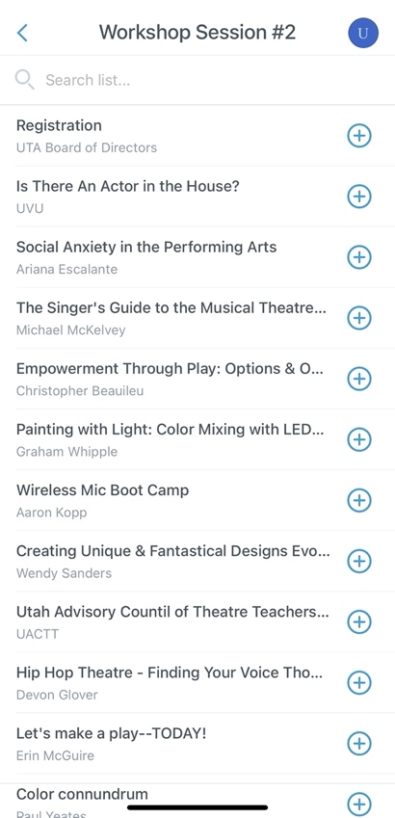
Here is the list of all the titles of the workshops available. Please choose more than one that you’d like to attend in case one gets full. You can click on the (+) to add it to your “To Do” list.

Click on the workshop title to find out it’s description and its location.

Don’t forget to check out all the other features in the guide.
- Guest Artist Bios
- Campus Maps
- Evening Production Information
- Award Winner Bios

At the end of your workshops, please click on “Conference Workshop feedback” and answer the questions. You may fill this out as many times as you want. You may also click on the individual workshop and give it a rating.

